ADDB exam paper

ST10053561

Varsity College

ADDB7311

**Table Of Contents**

Figure 1 : Question 1 3

Figure 2 : Question 2 3

Figure 3 : Question 3 4

Figure 4 : Question 4 4

Figure 5 : Question 5 5

Figure 6 : Question 6 5

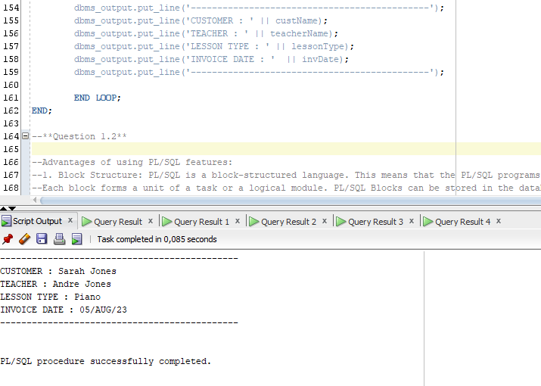

Figure : Question 1

Figure : Question 2

Figure : Question 3

Figure : Question 4

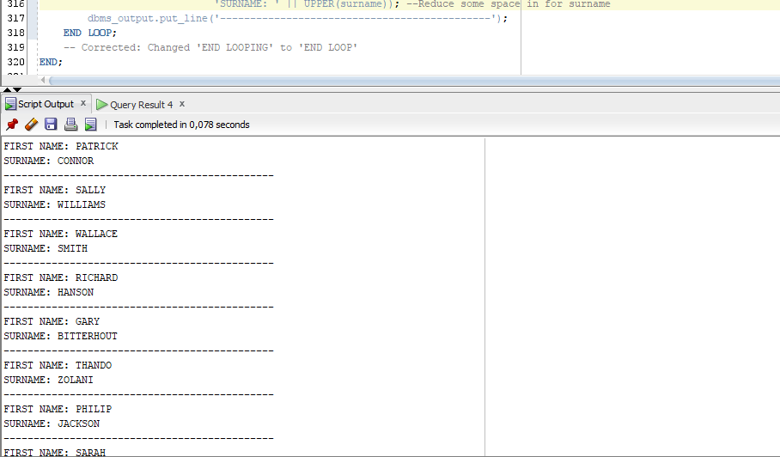

Figure : Question 5

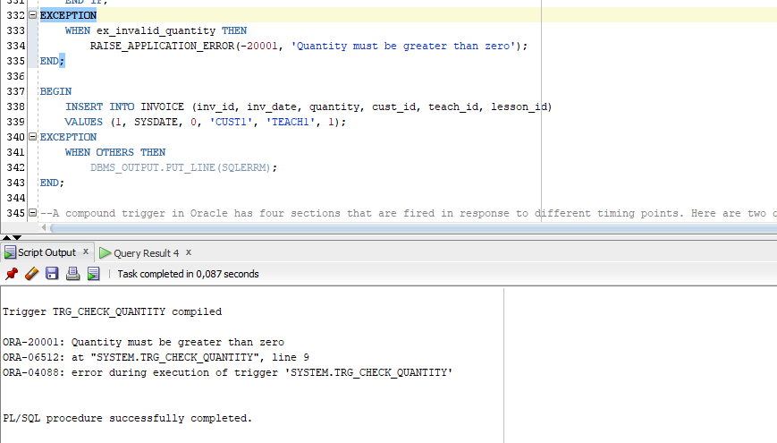

Figure : Question 6